The impact of investor sentiment and policy uncertainty on stock market volatility: Evidence from the Korean stock market

Appendix A: Data Construction Details
Stock Market Volatility
The daily KOSPI index level is obtained from the FnGuide database. This study computes log daily returns in percentage terms as $r_{i}$ and measures daily volatility as $r_{i}^{2}$. The monthly realized variance ($RV_{t}$) is calculated as the squared sum of daily returns within each month. Figure 1 illustrates the dynamics of the KOSPI index and its realized volatility, highlighting two high-volatility periods—the global financial crisis (2008–2011) and the COVID-19 pandemic (2020–2022)—as well as a relatively low-volatility period in between.
Policy Uncertainty
Monthly South Korean policy uncertainty indices are obtained from the Baker, Bloom, and Davis database (policyuncertainty.com), as developed by Cho and Kim (2022) following Baker et al. (2016). These include economic policy uncertainty (EPU), fiscal policy uncertainty (FPU), monetary policy uncertainty (MPU), trade policy uncertainty (TPU), and foreign exchange policy uncertainty (FEPU). Each index is constructed from frequency counts of predefined sets of policy-related terms appearing in Korean newspapers (see Tables 1 and A1–A5 in Cho and Kim (2022)). For example, the TPU index is based on the frequency of trade-related terms. In the analyses, this study uses the percentage growth rate of the log-transformed indices.
Investor Sentiment Variables
The Korean investor sentiment index is constructed by combining the variables proposed by Kim and Byun (2010), who follow the methodology of Baker and Wurgler (2007), with those suggested by Lee and Yoon (2018), who incorporate derivatives market information to enhance the informativeness of the sentiment measure. The variables include:
The first variable is individual investor’s monthly buy-sell imbalance (BSI) from Kumar and Lee (2006). If BSI is positive, it means that individual investors’ perspective is positive. This study collects individual investors’ currency-dominated buy and sell trading volume from the Bank of Korea, and calculate the BSI as the difference of buy and sell trading volumes, divided by the total trading volume. The second variable is the customers’ deposits for stock investment (CD). A positive CD shows that the investors are more optimistic. We collect the data from the Bank of Korea. Following Kim and Byun (2010), we detrend the current month’s deposit by its moving average for two years and divide it with the current month’s deposit to construct our CD variable. We use the turnover ratio (TURN) from the Bank of Korea as the third variable. It is the ratio of trading volume and number of shares outstanding. The fourth variable is the log consumer composite sentiment index (CCSI) by the Bank of Korea. The Bank of Korea provides this data from September 2008. This study collects additional data from the trading economics website to extend this data to January 2006. Fifthly, we use the ratio of positive volume minus the negative volume of the options market (OPTION). Positive option volume is the sum of the call buy and put sell volume, and negative volume is the sum of call sell and put buy volume. We collect this data from the Korean National Statistics Office.
The sentiment index constructed using principal component analysis. This study employs ten standardized variables (five aforementioned variables and their lagged variables) to get the first principal component. After that, The Pearson correlation coefficients of first principal component and the ten variables to choose the best timing option (the current variable or the lagged variable) for a second round of principal component analysis.
As a result, the sentiment variable is constructed as follows:
$$\begin{aligned}{SENT}_{t}=0.227*BSI_{t}+0.564{*CD}_{t}+0.727*TURN_{t-1} \\ -0.201*CCSI_{t-1}-0.248*OPTION_{t-1}\#\left(A1\right)\end{aligned}$$
The cumulative variance explained by the first principal component is 32.243%. While this value does not entirely explain the data, it does to some extent represent investor sentiment. For the main analyses, This study uses the monthly percentage innovation of sentiment variable. Figure 2 describes the time series of investor sentiment alongside its rate of change.

Appendix B: Out-of-Sample Prediction Test

Model Confidence Set (MCS) Test
This study employs the Model Confidence Set (MCS) test proposed by Hansen et al. (2011). This method requires the introduction of loss functions to assess the model's predictive error. Considering Diebold and Lopez (1996) perspective that determining the best loss function for forecasting volatility accuracy is challenging, this study selects three loss functions to evaluate the model's predictive error. These are the Mean Squared Error (MSE), Mean Absolute Error (MAE), and $R^{2}LOG$.
$$\begin{aligned}MSE=\frac{1}{n}\sum_{n=1}^{N}{{\left(σ_{t}^{2}-{\hat{σ}}_{t}^{2}\right)}^{2}}; MAE=\frac{1}{n}\sum_{n=1}^{N}{\left|σ_{t}^{2}-{\hat{σ}}_{t}^{2}\right|}; R^{2}LOG=\frac{1}{n}\sum_{n=1}^{N}{{\left(\ln{\frac{σ_{t}^{2}}{{\hat{σ}}_{t}^{2}}}\right)}^{2}}\#\left(A2\right)\end{aligned}$$
The notation $σ_{t}^{2}$ represents the realized variance, while ${\hat{σ}}_{t}^{2}$ denotes the estimated values derived from the model. To make a comparison, we include GARCH(1,1), GJR-GARCH(1,1), and GJR-GARCH-MIDAS models of each variable in the Model Confidence Set (MCS). The maximum t-value $T_{max,M}$ and the range statistic $T_{R,M}$. If the values exceed the given critical threshold, the null hypothesis is rejected. Here, $d_{a,b}$ represents the difference in losses between models a and b in set M. $\hat{var}({\overline{d}}_{a})$ and $\hat{var}({\overline{d}}_{a,b})$ are estimations of ${\overline{d}}_{a}$ and ${\overline{d}}_{a,b}$, respectively, obtained using stationary block bootstrap.
$$\begin{aligned}T_{max,M}=max*\frac{{\overline{d}}_{a}}{\sqrt{\hat{var}\left({\overline{d}}_{a}\right)}}; T_{R,M}=max*\left|\frac{{\overline{d}}_{a,b}}{\sqrt{\hat{var}\left({\overline{d}}_{a,b}\right)}}\right|, for a,b∈M\#\left(A3\right)\end{aligned}$$

Liu et al. (2018) and Wang et al. (2020) demonstrate that setting the threshold to 0.10 aids in selecting the best model. Hence, this study chooses to set the p-value for the MCS to 0.10. The p-values are determined from 10000 block bootstraps.

Diebold and Mariano (DM) Test
Next, this study compares the predictive accuracy of two models using the Diebold and Mariano (DM) test (Diebold & Mariano, 2002), which evaluates the predictive ability of two models. The null hypothesis of the DM test assumes that both forecasting models possess an equal predictive ability. Hence, if the p-value is less than the significance level, the null hypothesis is rejected, indicating a statistically significant difference in predictive performance.$\begin{aligned}DM=\frac{\overline{d}}{\sqrt{var\left(d_{s}\right)}}\sim N\left(0,1\right), d_{s}=E_{a,s}^{2}-E_{b,s}^{2}\#\left(A4\right)\end{aligned}$

$E_{a,s}$ and $E_{b,s}$ represent the prediction errors of models a and b, respectively. $\overline{d}$ denotes the average value of the time series $d_{s}$, while $var(d_{s})$ stands for the variance of $d_{s}$.

References
Baker, M., & Wurgler, J. (2007). Investor Sentiment in the Stock Market. Journal of Economic Perspectives, 21(2), 129–152. https://doi.org/10.1257/jep.21.2.129
Baker, S. R., Bloom, N., & Davis, S. J. (2016). Measuring Economic Policy Uncertainty*. The Quarterly Journal of Economics, 131(4), 1593–1636. https://doi.org/10.1093/qje/qjw024
Cho, D., & Kim, H. (2022). Macroeconomic effects of uncertainty shocks: Evidence from Korea. Journal of Asian Economics, 84, 101571. https://doi.org/10.1016/j.asieco.2022.101571
Diebold, F. X., & Lopez, J. A. (1996). 8 Forecast evaluation and combination. In Handbook of Statistics (Vol. 14, pp. 241–268). Elsevier. https://doi.org/https://doi.org/10.1016/S0169-7161(96)14010-4
Diebold, F. X., & Mariano, R. S. (2002). Comparing Predictive Accuracy. Journal of Business & Economic Statistics, 20(1), 134–144. https://doi.org/10.1198/073500102753410444
Hansen, P. R., Lunde, A., & Nason, J. M. (2011). The Model Confidence Set. Econometrica, 79(2), 453–497. https://doi.org/10.3982/ECTA5771
Kim, K., & Byun, J. (2010). Effect of Investor Sentiment on Market Response to Stock Split Announcement. Asia-Pacific Journal of Financial Studies, 39(6), 687–719. https://doi.org/10.1111/j.2041-6156.2010.01029.x
Kumar, A., & Lee, C. M. C. (2006). Retail Investor Sentiment and Return Comovements. The Journal of Finance, 61(5), 2451–2486. https://doi.org/10.1111/j.1540-6261.2006.01063.x
Lee, M.-h., & Yoon, S.-j. (2018). An Informative Independence of Investor Sentiment Indices in the KOSPI 200 Options Market. Journal of Money and Finance, 32(1), 1–44. https://doi.org/10.21023/JMF.32.1.1
Liu, J., Ma, F., Yang, K., & Zhang, Y. (2018). Forecasting the oil futures price volatility: Large jumps and small jumps. Energy Economics, 72, 321–330. https://doi.org/10.1016/j.eneco.2018.04.023
Wang, L., Ma, F., Liu, J., & Yang, L. (2020). Forecasting stock price volatility: New evidence from the GARCH-MIDAS model. International Journal of Forecasting, 36(2), 684–694. https://doi.org/10.1016/j.ijforecast.2019.08.005

Figure 1. The stock market return and monthly realized volatility
On the left side, it shows the log-differenced daily returns of the KOSPI index from January 2, 2006, to December 29, 2022, and on the right side, it presents the monthly realized volatility from January 2006 to December 2022.
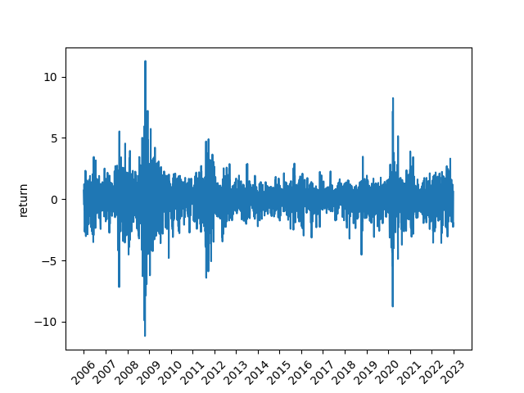 | 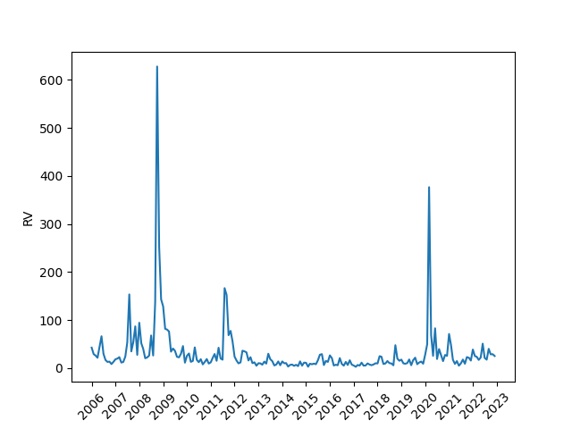
Return | Volatility

Figure 2. Time-series of the sentiment index
This figure presents the sentiment index and its changes. The changes are multiplied by 100.
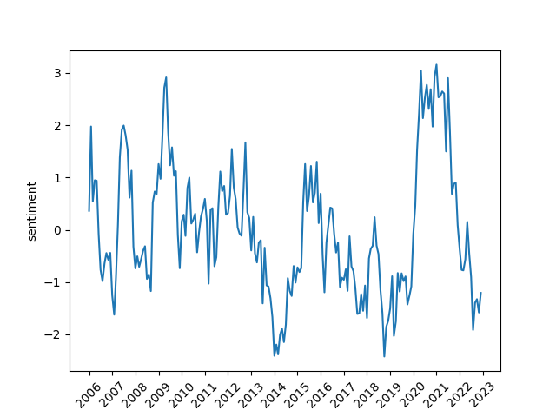 | 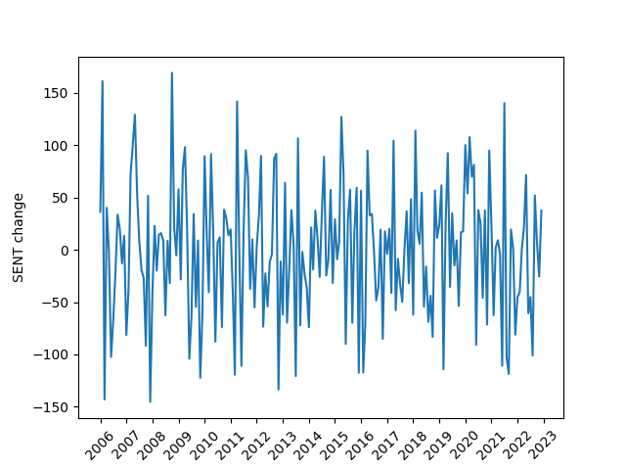
SENT | $$ΔSENT$$

tradingeconomics.com

